# Business-Requirement:

## Problem Statement:

The purpose of this application is to allow the visitors to deal company details and stock price index.

### Company Module:

**The Company Module** allows you to:

1. Access Portal’s home page
2. Visitor should be able to add a new company detail
3. Company can have basic fields along with mention of Stock exchange (pre-defined) it is listed in (Ex: BSE, NSE)
4. Visitor should be able to get the list of Companies against each Stock Exchange

### Stock Price Index Module:

**The Stock Price Index Module of application** allows you to:

1. Visitor allowed to add multiple stock prices of the company (based on date and time)
2. Visitor should be able to search Company by name and show details of company with list of stock prices ordered on date and time
3. Visitor should be able to select a Company details from the list and date range.
4. Need to show the minimum, maximum and average stock prices of company on selected date range

# 2. Resources Available :

|  |  |  |
| --- | --- | --- |
| Description | View Pages Name | Remarks |
| Common UI |  |  |
| Home Page | index.jsp | Contains Login form for Admin and link to new user page |
| Error Page | errorPage.jsp |
| Header | header.jsp |
| Footer | footer.jsp |
| Not Found Page | notfound.jsp |
|  |  |  |
| Company Services UI |  |  |
| Shall contain ‘Entry Form’ for new Company Details | addCompanyInfo.jsp | Must use input field names as cid, cname, cdirectors, cprofile |
| Shall use to show list of all Companies | listAllCompanies.jsp |
|  |  |  |
| Stock Price Index Services UI |  |  |
| Shall contain ‘Entry Form’ for new Stock Prices | addStockPrices.jsp | Must use input field names as ccode, cstockprice, cdate |
| Shall show list of Stock available for a Company | displayStockDetails.jsp |
| Shall show list of Stock Price Index | showStockStatistics.jsp |
|  |  |  |
| Admin Login Id | admin |  |
| Admin Password | admin |  |

# Page Flow :

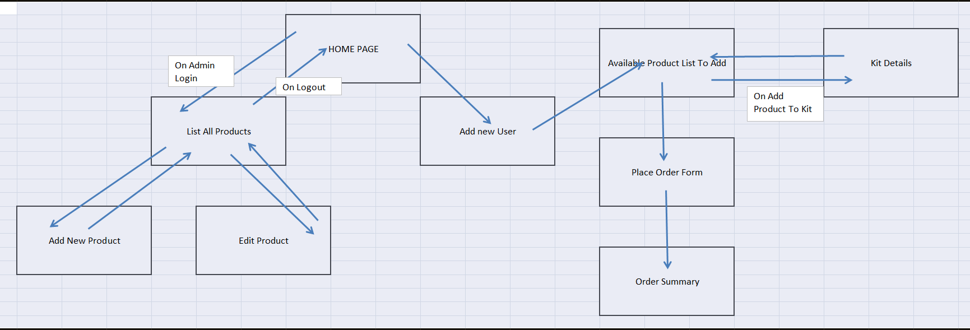

# SQL For Application :

Create database stockmarketdb;

use stockmarketdb;

CREATE TABLE CompanyDetails (companyCode Long(11) AUTO_INCREMENT,

companyName VARCHAR(50),

companyCEO VARCHAR(50),

stockExchange VARCHAR(50),

boardOfDirectors VARCHAR(255),

companyProfile VARCHAR(255),

CONSTRAINT key1 PRIMARY KEY (companyCode)

);

CREATE TABLE StockPriceDetails( Id Long(11) AUTO_INCREMENT,

companyCode Long(11),

currentStockPrice double(8,2),

stockPriceDate LocalDate,

stockPriceTime LocalTime,

CONSTRAINT key1 PRIMARY KEY (Id)

);

# SQL for Testing:

Create database stockmarketdb;

use stockmarketdb;

CREATE TABLE CompanyDetails (companyCode Long(11) AUTO_INCREMENT,

companyName VARCHAR(50),

companyCEO VARCHAR(50),

stockExchange VARCHAR(50),

boardOfDirectors VARCHAR(255),

companyProfile VARCHAR(255),

CONSTRAINT key1 PRIMARY KEY (companyCode)

);

CREATE TABLE StockPriceDetails (Id Long(11) AUTO_INCREMENT,

companyCode Long(11),

currentStockPrice double(8,2),

stockPriceDate LocalDate,

stockPriceTime LocalTime,

CONSTRAINT key1 PRIMARY KEY (Id)

);

# Commands:

Commands to run:

From inside of Project Folder

* + - 1. mvn clean package
      2. java -jar target/dependency/webapp-runner.jar target/stockmarket.war